British Antarctic Survey Medical Unit process.
This is a step-by-step guide to obtaining and submitting your medical documentation to BASMU. This document is intended for use by all deploying BAS staff and visitors.
If you require further information or need assistance submitting your forms, please contact BASMU on basmu.admin@nhs.net, Tel: +44 (0) 1752 438621, or by contacting BAS HR.

- Inform BASMU of your intent to deploy by completing the BASMU 1

Access the BASMU 1 and 2 forms from the BAS website Medical guidelines and forms - British Antarctic Survey (bas.ac.uk)
Complete the form on the BASMU 1 and send to BASMU via email to basmu.admin@nhs.net
Please note - BAS staff must re-submit the registration form for all subsequent deployments.
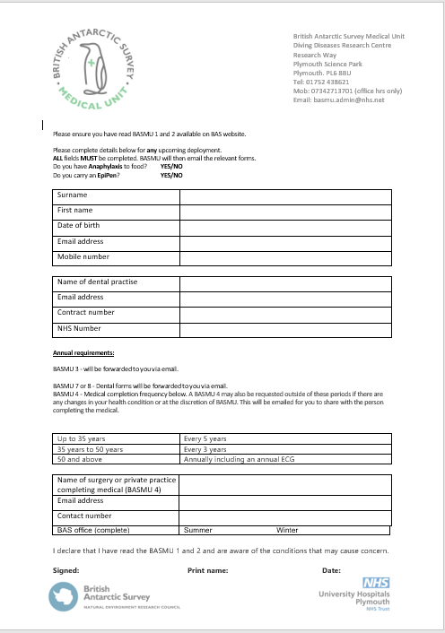
BASMU 1 registration form

BASMU will use this information to create your patient record on BASMU’s Private Practice System (PPS). Through the PPS, BASMU will email you secure, individual links to the relevant medical forms you will be required to complete.

- BASMU-3 (self-assessment)

BASMU will email you a link to your secure online BASMU-3 form, followed by a passcode via text that will allow you to access the form and securely enter your data.

The BASMU-3 takes approximately 20 minutes to complete. Please note – the form does not autosave, therefore allow time to complete in one session. Please provide as much information as possible.

The electronic form allows you to free-hand a signature using your cursor or track-pad. Click submit on the form once all fields are complete. This will automatically return the form through BASMU’s secure Private Practice System.
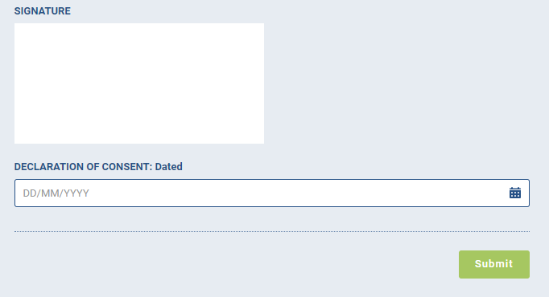
Screenshot of BASMU-3 signature field and submit button

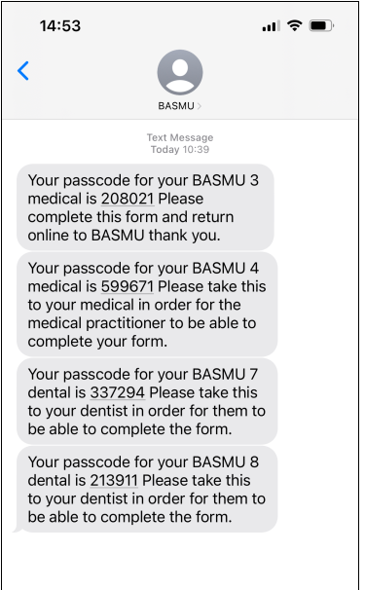
Screenshot of example passcode SMS

- BASMU-7 (summer staff dental) / BASMU-8 (overwinterer’s dental)

It is important to inform BASMU of the duration of your deployment (or whether you are overwintering) as soon as possible, as this will determine which dental form you are sent to complete.

BASMU will email you a link to your secure online BASMU-7 or 8 form, followed by a passcode via text that will allow access to the form.

You must forward the link to the dental form to your chosen dental practitioner for them to complete at your appointment. You will need to take the passcode with you at the time of your dental examination.

N.B – BASMU-8 requires you to obtain X-rays. BASMU’s PPS does not yet support image transfers. Please email images of your X-rays to BASMU via email basmu.admin@nhs.net

- BASMU-4 (medical screening form)

BASMU will identify whether you are required to complete a medical examination and will email you a link to your secure online BASMU-4 form, followed by a passcode sent via text.

Once you have identified a medical practitioner and secured an appointment, you must forward the link to the doctor who will be carrying out your examination. You must take the passcode with you to the appointment so that the doctor can access the form.

The medical examiner will complete the online form and will click submit to securely transfer your medical notes back to BASMU via BASMU’s Private Practice System.

BASMU’s PPS does not yet support image transfers. Please email any additional documents, such as ECGs, to BASMU via email basmu.admin@nhs.net

N.B – BASMU’s doctors have direct access to the Private Practice System, so if your screening appointment is with a BASMU doctor on site at BAS Cambridge, you do not need to forward the form link.

You will receive automatic reminders if your forms remain outstanding.
If there are any issues, please do not hesitate to contact us at
British Antarctic Survey Medical Unit
Diving Diseases Research Centre
Research Way
Plymouth Science Park
Plymouth. PL6 8BU
Tel: 01752 438621
Mob: 07342713701 (office hrs only)
Email: basmu.admin@nhs.net

